**Configuring Portal database in free local db version**

1. Open Visual Studio 2012 in Administrator mode.
2. Go to Menu View- > Server Explorer
3. In Server explorer , right click on “Data Connections” and select “Add connection” as shows below

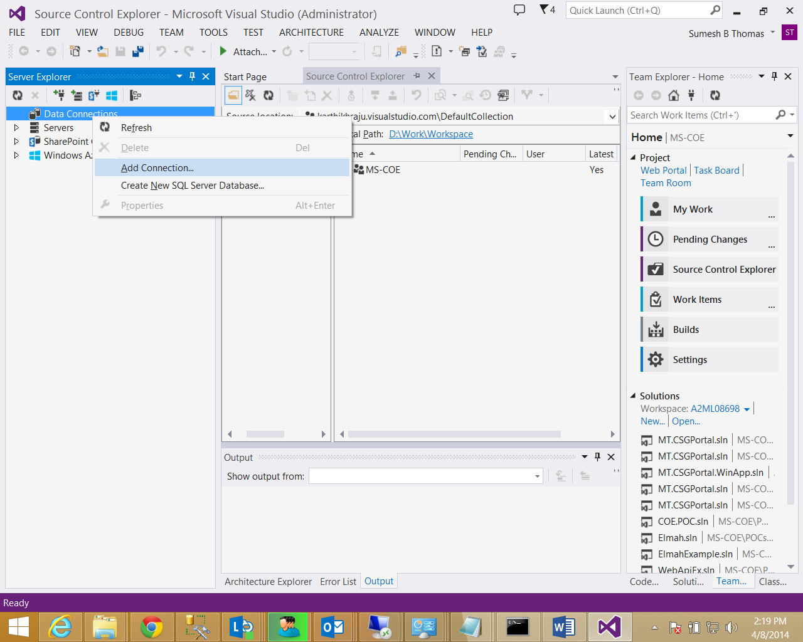

Figure Server Explorer window

1. Select SQL Server from the list as shown below

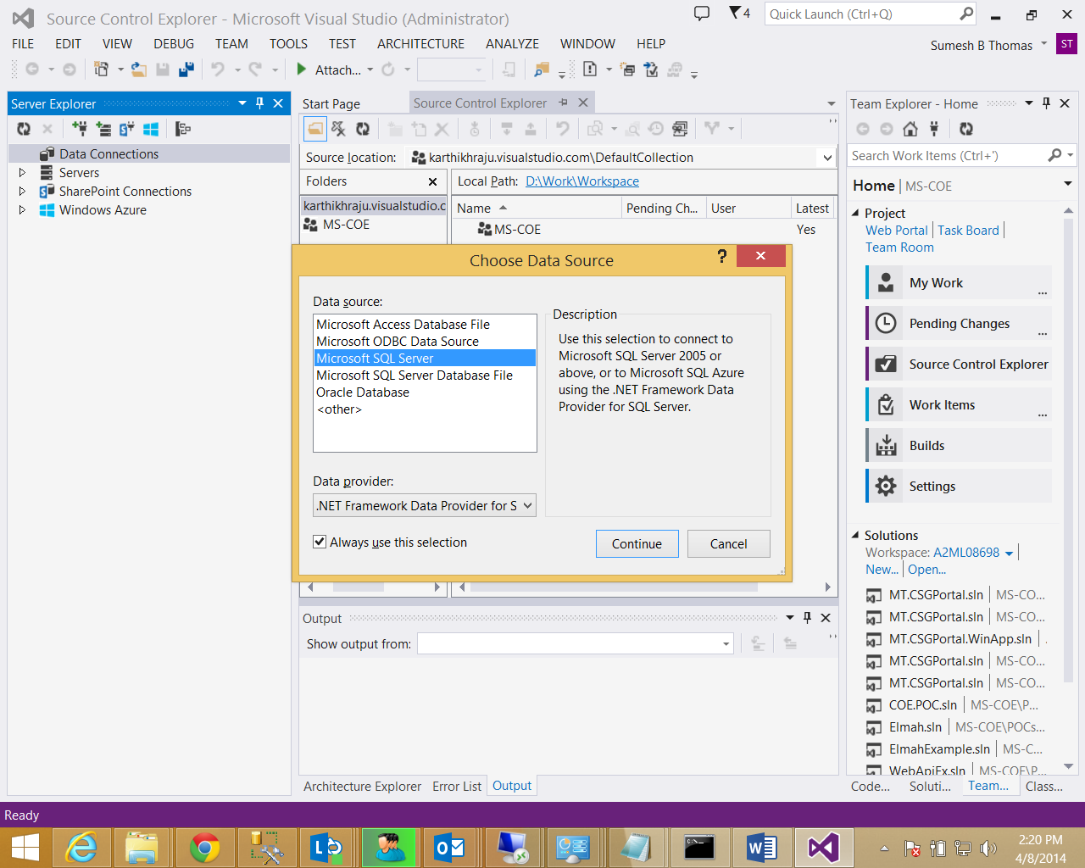

Figure Add new data connection

1. In the Add connection screen, enter **Server Name as “(localdb)\v11.0”**

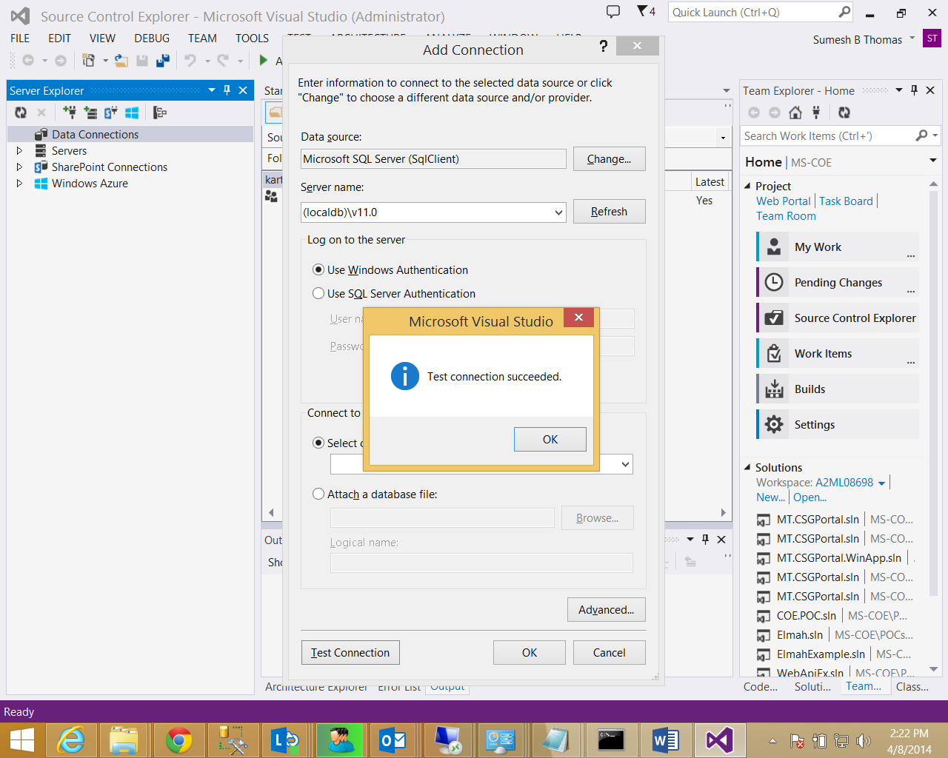

Figure Verify Test connection

1. Click “OK”
2. Right click the newly added server node and select new Query

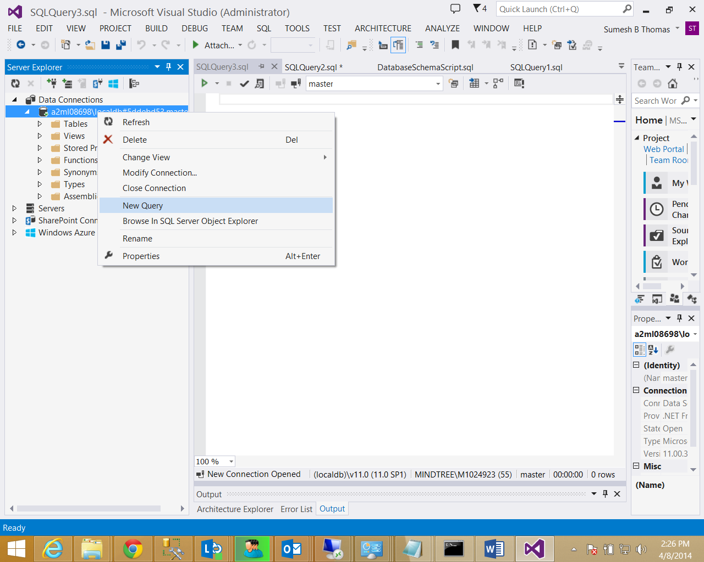

Figure Opening the new query window

1. The path of the data and log files is hard coded to D:\Data\CSGPortal.mdf & D:\Data\CSGPortal.ldf in the DatabaseSchemaScript.sql under the “DB Scripts” directory . Verify that the folder **D:\Data exists**. If there any change in folder structure then update it in the DatabaseSchemaScript.sql file
2. Copy the contents of the “DatabaseSchemaScript.sql” file and execute it.

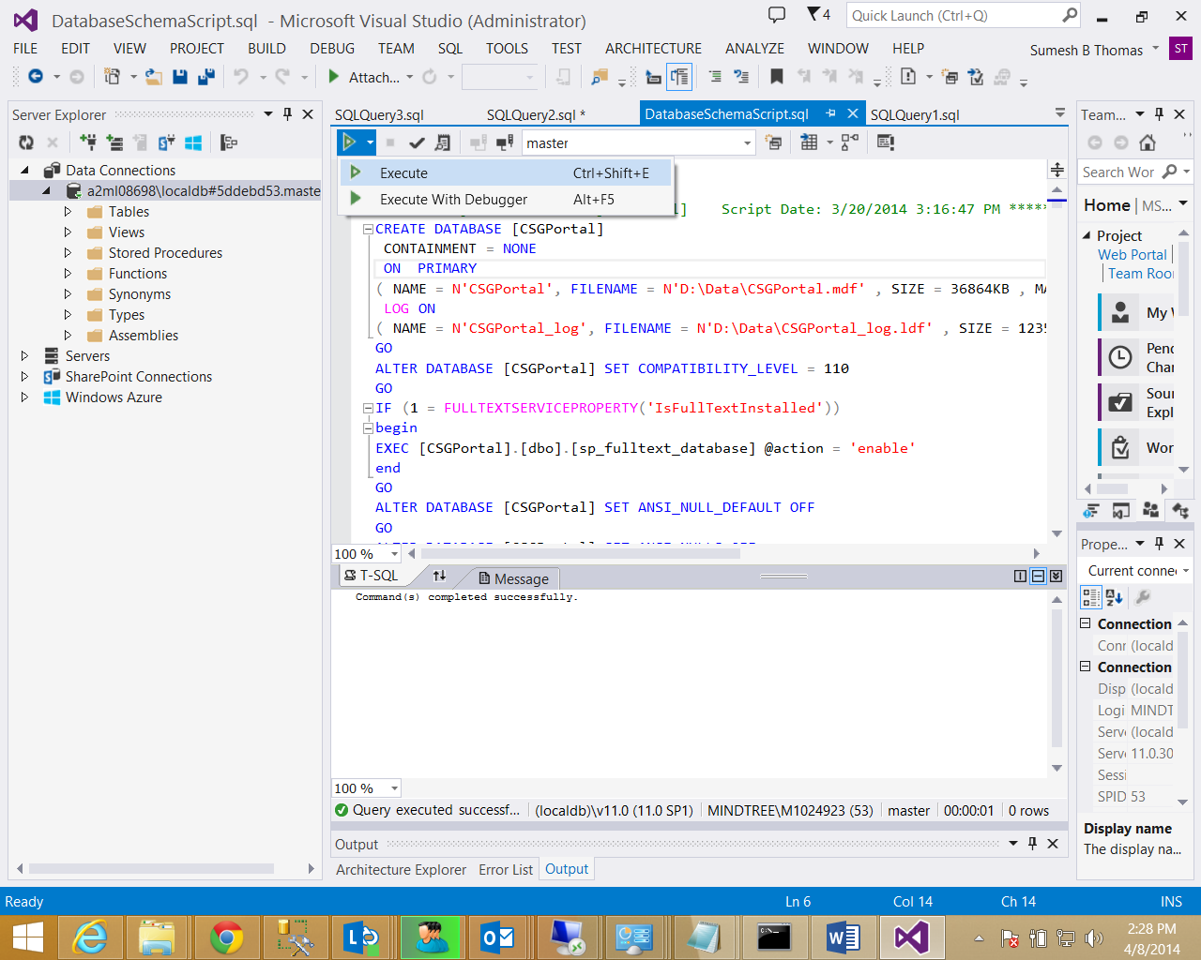

Figure Execute the sripts

1. Execute the scripts “LookupDataScript.sql” and “SampleDataScript.sql” in the same order and verify that there are no errors.
2. Once the scripts execution is complete , you can add a new connection to “CSGPortal” database and work with this like you do in Enterprise Manager as shown in Figure 7Verify that you are connected to CSGportal database

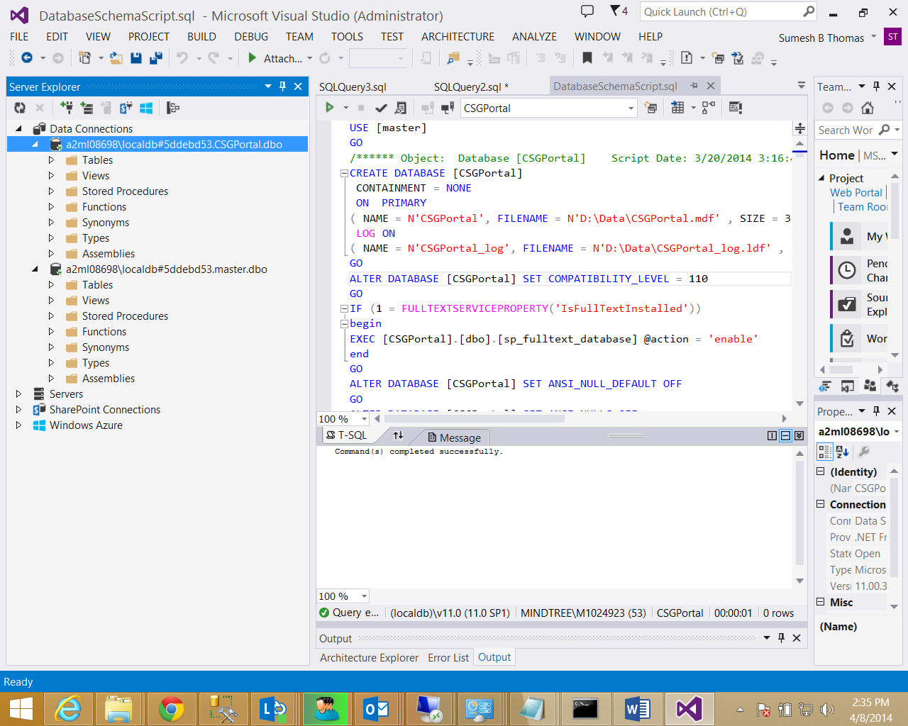

Figure Scripts executed successfully window

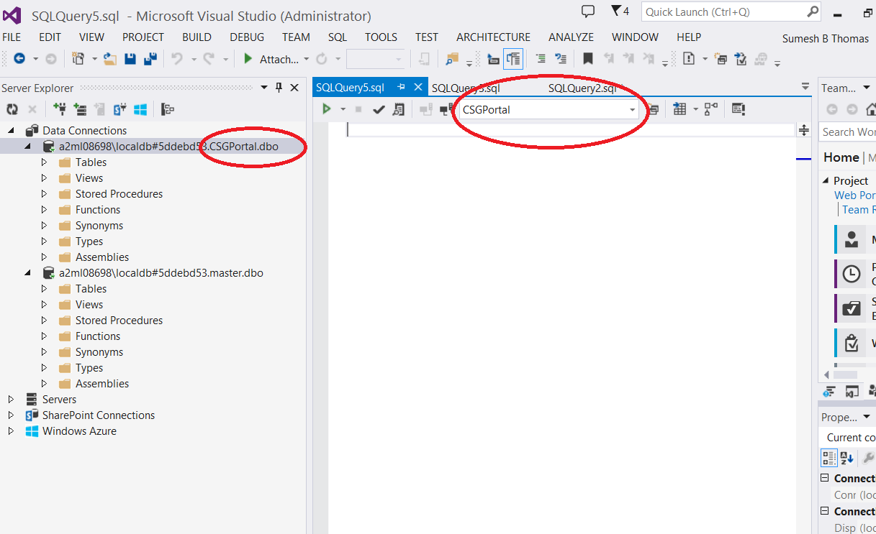

Figure Verify that you are connected to CSGportal database